SRI KONDA LAXMAN TELANGANA STATE HORTICULTURE UNIVERSTIY

FIELD VISIT TO VILLAGES AFFECTED BY HAIL STORM AND CONTINUOUS RAINS IN SIDDIPET DISTRICT
As per the oral instructions of the Director of Research, SKLTSHU, Mulugu, Dr. D. Anitha Kumari, PS (Entomology) along with Dr. B. Neeraja Prabhakar, Vice-Chancellor, SKLTSHU and Dr. A. Bhagwan, Director of Research, SKLTSHU, Mulugu visited Thimmapur, Basvapur and Munigadapa villages of Jagdevpur mandal, Siddipet district on 24th March, 2023 which were affected by hail storms on 17th and 18th March, 2023 and rains from 17th-19th March, 2023.
Thimmapur Village:
Tomato and Chilli crops of this village were affected by hail storm and rains from 17-19th March, 2023. In tomato flower drop, fruit splitting, mechanical injury was observed. In green chilli thrips incidence, die back was noticed.
Basavapur:
Tomato, Chilli and Cucumber crops of this village were affected by hail storm and rains from 17-19th March, 2023. In tomato flower drop, in chilli thrips incidence,and die back were observed and in cucumber splitting of leaves and dropping of flowers was observed.
Munigadapa:
In mango orchard which is around 100 acres fruit drop and fruit cracking was noticed.

Details of farmer’s fields visited:
 | Name of the Farmer | Crop | Acreage | Remarks | Recommendations
Thimmapur Village
1 | Dandu Narsimhulu | Chilli | 30 guntas | The crop is in flowering stage and thrips incidence and die back was noticed. | Spray application of Fipronil @ 0.2 grams/litre. Application of COC @ 3g/l.
 | -do | Tomato | 05 guntas | Fruit cracking due to mechanical injury caused due to hail storm | Raised bed method of cultivation and staking were recommended.  Borax @ 2.0-3.0 g/litre of Disodium octa borate spray @ 1.5-2.0 g/litre
Basvapur Village:
1 | Venkat Raji Reddy | Tomato | 30 guntas | Flower drop | Raised bed method of cultivation and staking were recommended.  Spray application of Planofix @1ml /4.5 litres of water  Micronutrient mixture spray application @5g/litre
 |  | Chilli | 30 guntas | The crop is in flowering stage and thrips incidence and die back was noticed. | Spray application of Fipronil @ 0.2 grams/litre. Application of COC @ 3g/l.
2 | Sreedhar Reddy | Cucumber | 30 guntas | Splitting of leaves and drooping of plants | Raised bed method of cultivation and staking were recommended.  Spray application of 13-0-45 @5g/litre
Munigadapa Village
1 | Vidhyasagar Rao | Mango | 100 acres | Fruit drop and fruit cracking was observed | Harvesting of fruits with Dapoli harvester was demonstrated

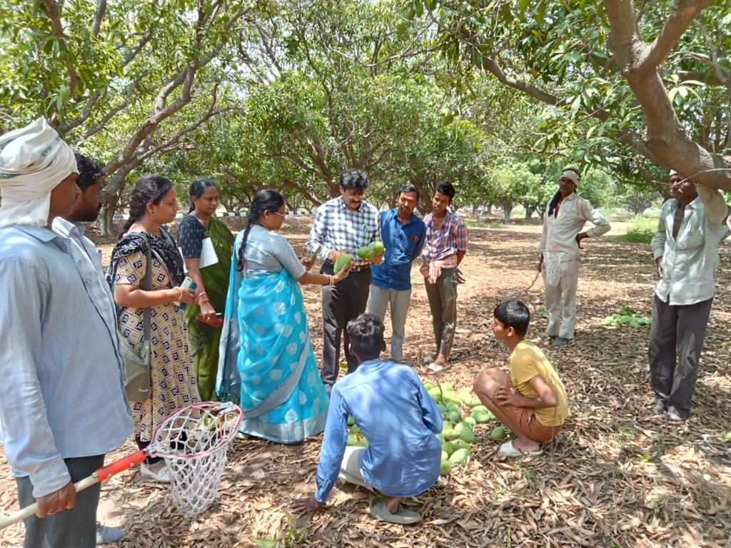 | 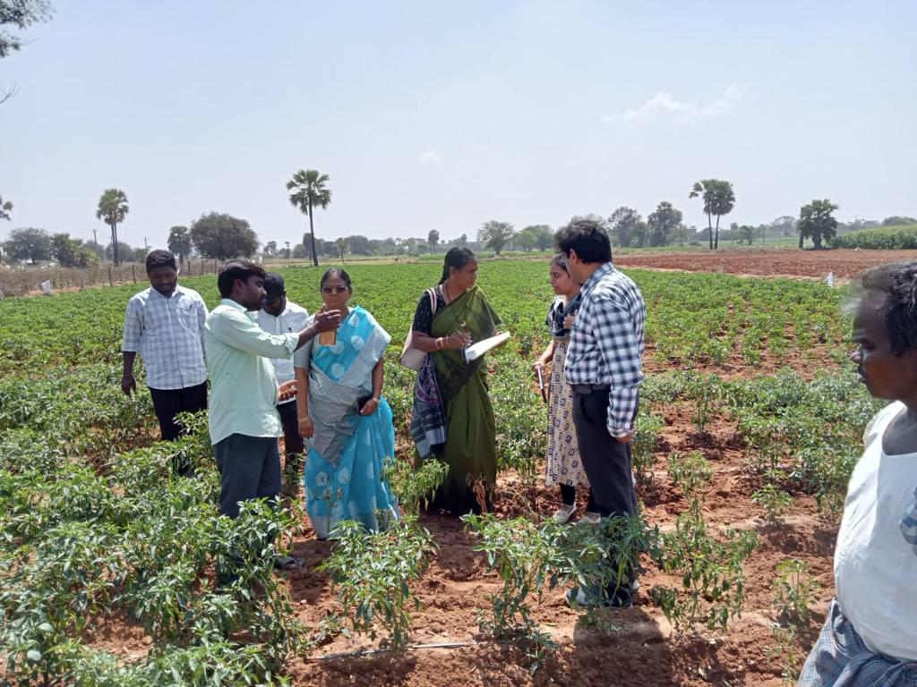
Damage in Mango Orchard | Damage in Chilli
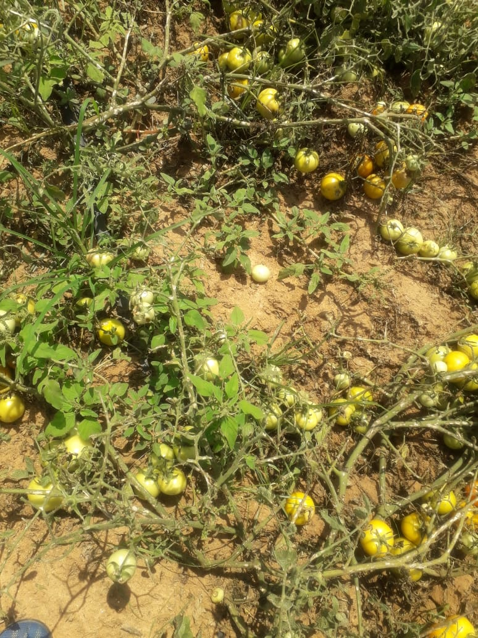 | 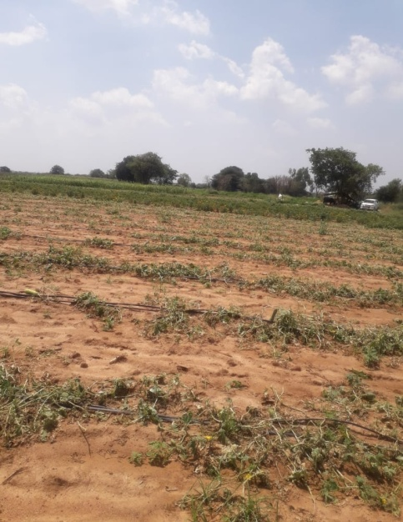
Damage in Tomato | Damage in Cucumber

FIELD VISIT TO VILLAGES AFFECTED BY HAIL STORM AND CONTINUOUS RAINS IN VIKARABAD DISTRICT
As per the instructions of the Director of Research vide Cir. Memo. No.96/SKLTSHU/2022-23 dated 20.03.2023 of the Director of Research, SKLTSHU, Mulugu, Dr. D. Anitha Kumari, PS (Entomology) and Dr. R. Preetham SS (Agronomy) visited Erravalli and Madanpalli Villages of Vikarabad Mandal and District on 21st March, 2023 which were affected by hail storms on 17th and 18th March, 2023 and rains from 17th-19th March, 2023.
Erravalli Village:
Tomato, Maize, Green Chilli and cauliflower crops of this village were affected by 3-5 cm diameter ice crystals which fell for 10-15 minutes on 17th and 18th March, 2023 and rains from 17-19th March, 2023. In tomato flower drop, fruit splitting, mechanical injury was observed. In green chilli also flower drop was noticed. In cauliflower the crop was at curd formation stage and due to hail storm leaves were damaged. In maize, the crop was at milking and grain development stage, due to hail storm, splitting of leaves and drooping of plant was noticed. The team of scientists from Vegetable Research Station, Rajendranagar was accompanied by Dr. M Anand garu, MLA, Vikarabad constituency, Sri. Chakrapani garu, DHSO, Vikarabad.
Madanpalli Village:
Chilli, Cabbage, Rose, Chrysanthemum, Mago and Papaya field were affected by the 3-5 cm ice crystals which fell for 10-15 minutes during hail storm on 17th and 18th March, 2023 and rains from 17th -19th March, 2023. In maize splitting of leaves and drooping of plant was observed, in rose and chilli flower drop was noticed, in cabbage holes on heads were observed. In Kondi Manemma (farmer) mango orchard 40 mango trees (33 Baneshan, 4 Dasheri and 3 Himayath) were severely damaged due to heavy winds and hail storms, the trees fell, roots were exposed. The chrysanthemum fields were infected with fungal diseases. Papaya plant leaves were damaged.

Details of farmer’s fields visited:
s.nO | Name of the Farmer | Crop | Acreage | Remarks | Recommendations
Erravalli Village:
1 | Venkat Reddy | Cauliflower | 2 acre | The crop is in curd formation stage, leaves were severely damaged | Spray application of 13-0-45 twice at 7 days interval
2 | -do | Mango | On bunds | Fruit cracking due to mechanical injury caused due to hail storm | Borax @ 2.0-3.0 g/litre of Disodium octa borate spray @ 1.5-2.0 g/litre
3 | -do- | Moringa | Bunds | Plant and trees fell down
4 | Saidapuram Ananth Reddy | Tomato | 2 acres | Flower drop and mechanical injury to plants | Spray application of Planofix @1ml /4.5 litres of water  Micronutrient mixture spray application @5g/litre
5 | -do- | Maize | 1 acre | Mechanical damage, splitting of leaves and drooping of plants | Spray application of 13-0-45 @5g/litre
6 | S.Ravindar Reddy | Chilli | 1 acre | Flower drop | Spray application of Planofix @1ml /4.5 litres of water  Micronutrient mixture spray application @5g/litre
Madanpalli Village:
1 | Basireddy Narsimha Reddy | Rose | 30 guntas | Flower drop | Spray application of Planofix @1ml /4.5 litres of water  Micronutrient mixture spray application @5g/litre
2 | Basireddy Narsimha Reddy | Maize | 30 guntas | Splitting of leaves and drooping of plants | Spray application of 13-0-45 @5g/litre
3 | Basireddy Ananth Reddy | Chilli | 1 acre | Flower drop | Spray application of Planofix @1ml /4.5 litres of water  Micronutrient mixture spray application @5g/litre
4 | B Laxma Reddy | Cabbage | 30 guntas | Holes on heads | Immediate disposal to the market without delay
5 | Shareef | Chrysanthemum | 20 guntas | Fungal diseases | Spray application of mancozeb + carbendazim (Saaf) @2 g/litre
6 | P. Hanmanthu | Papaya | 1.75 acre | Crop is 2 months old, mechanical damage due to hail storm | Gap filling with new seedlings to maintain plant stand
7 | Kondi Manemma | Mango | 3 acres | 40 mango trees were severely damaged (33 Baneshan, 4 Dasheri and 3 Himayat) | Removal of the damaged plants and gap filling with new seedlings in the next rainy season

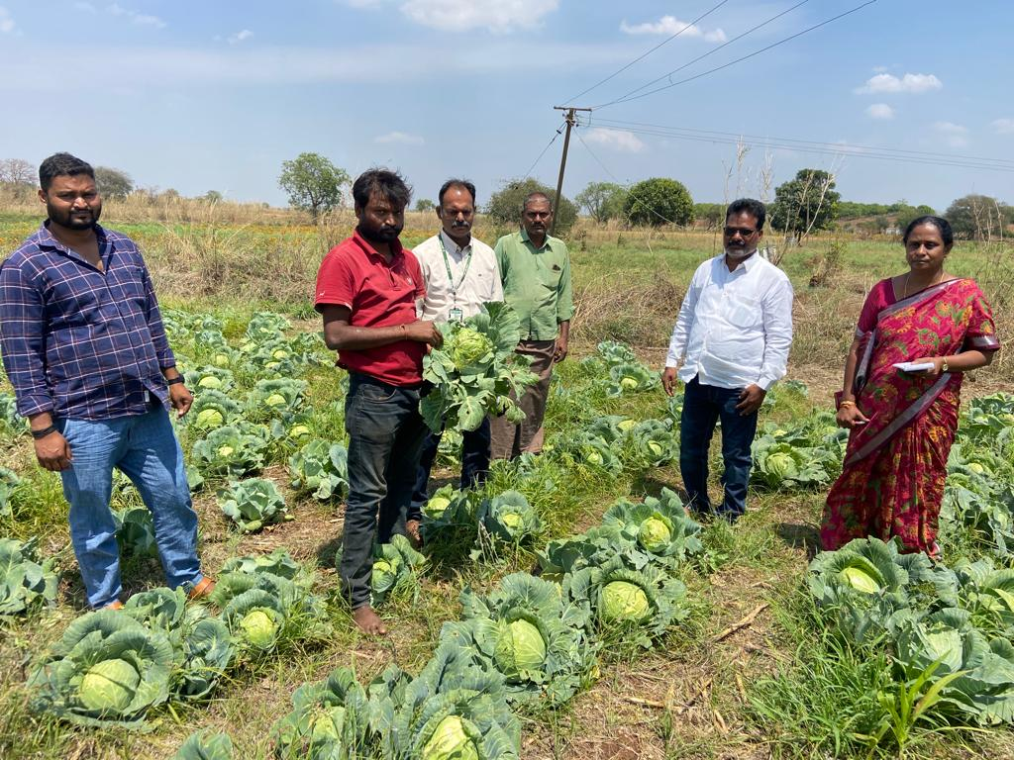
FIELD VISIT OF CABBAGE FARMER

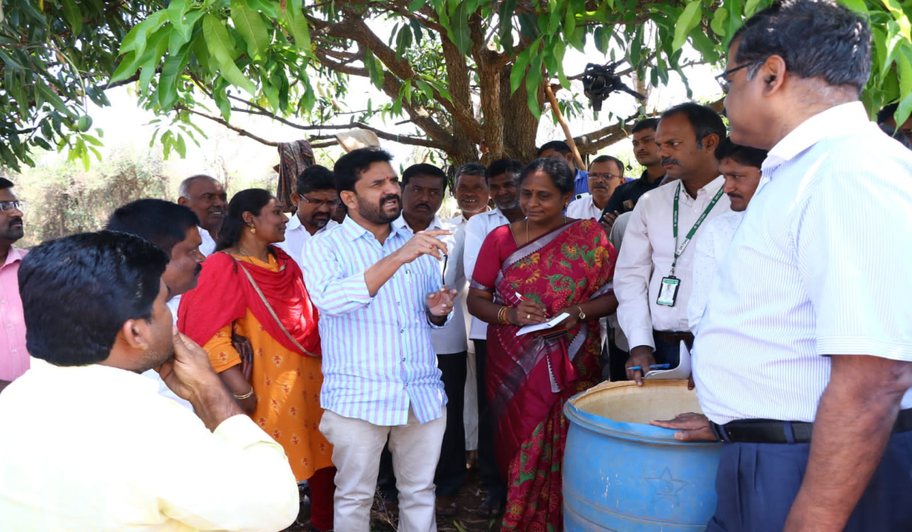

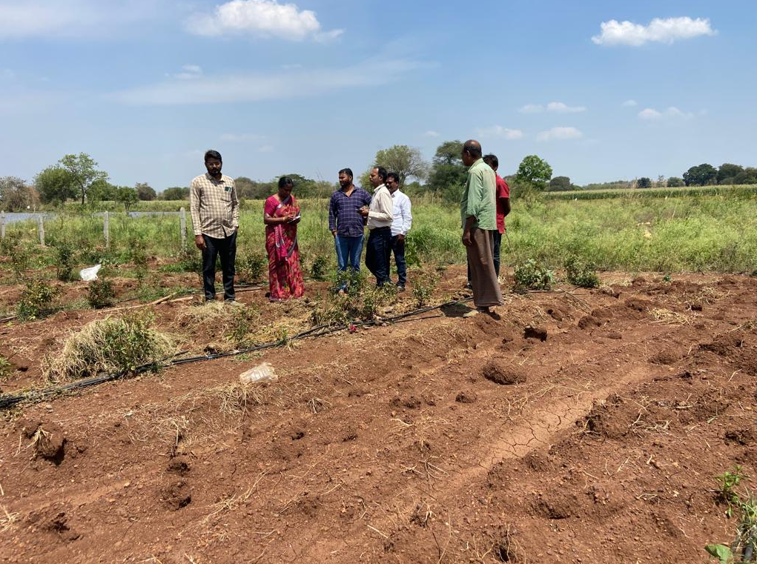

Scientist and department officials inspecting the rain affected area of Vikarabad

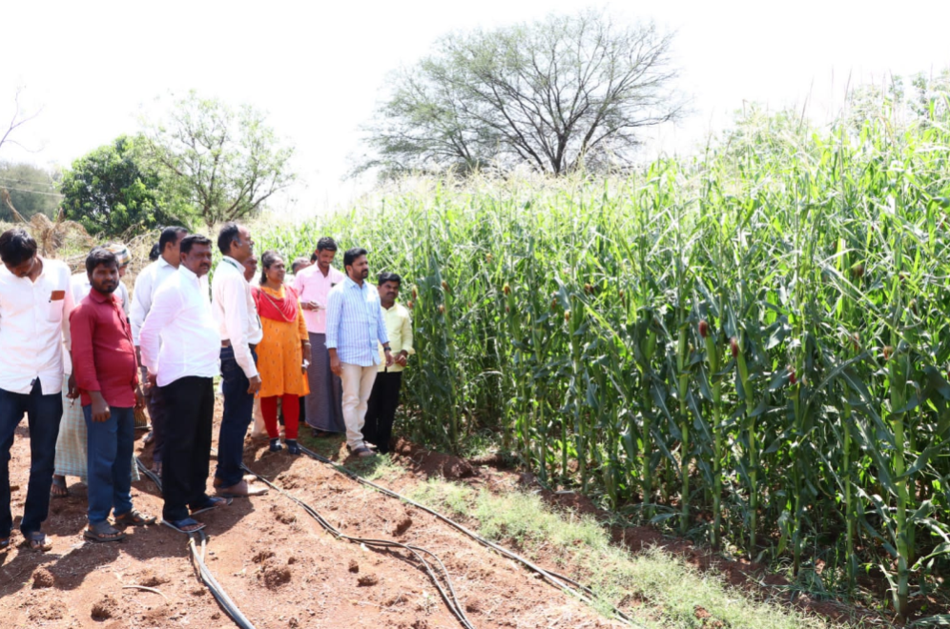

Compliance Report of field diagnostic visit on 20-03-2023
As per the instructions of the Director of Research, SKLTSHU vide Cir.Memo No 96/SKLTSHU/2022-23. Dated 20-03-2023, a team of scientists led by Dr.T.Suresh Kumar Reddy, Principal Scientist (H) & Head & Zonal Head Sothern Telangana Zone along with Dr.D.Anitha Kumari, Principal Scientist (Ento) & Head, Dr.R.Preetham Goud, Senior scientist (Agronomy),Vegatable Research Station and Dr.Zehra Salma, Scientist (Floriculture) of Floricultural Research Station visited Laxmi tanda of Bhahadurguda village in Shamshabad mandal affected by sudden hail storm and rains.
The team visited Tomato, Chilli, Cabbage, Colocasia, Leafy vegetables and Rose fields.
Rose :
Rose variety Scentu gulabi was grown, due to hail storm 40% of flowers were damaged and could get 60 kg flowers in place of 100 kg normal harvest for 2.5 acres. Crown gall was also observed in older plants.
In rose variety Bullet, thrips infestation and micronutrient deficiency was also observed.
Suggestions:
Remove excess water from field. Make necessary arrangements by digging water outlets or channels to prevent stagnation of water due to heavy rains. Remove the crown gall affected areas and drench the soil (Roots) with streptocyclin 0.6 ml per litre solution.
For control of thrips Fipronil 2 ml /litre spray and micronutrient spray 4 g/l at fortnight interval.
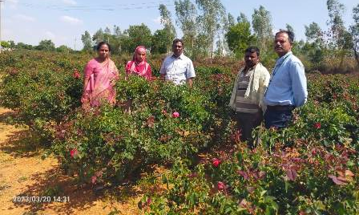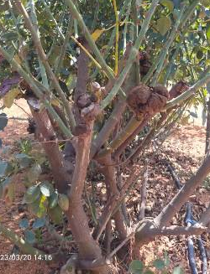
Rose field infested with crown gall
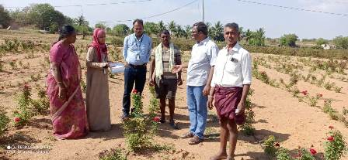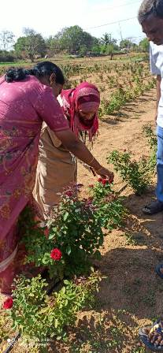
Rose Field
Tomato:
The Lyco variety of tomato is grown. The crop was in flowering and fruiting stage. Due to hail storm flower drop was observed.
Suggestions: Spray Planofix @1 ml/4-5 litres of water to prevent flower drop.
Chilli:
Ujala variety of chilli is being grown, severe infestation with black thrips was observed.
Suggestions: Errection of Blue sticky traps 30-35/acre and neem oil 1% @ 5 ml/l prophylactic spray and fipronil spray @ 2ml/l . Removal of weeds around the bunds and channels.prevent use of excessive nitrogen fertilizers.
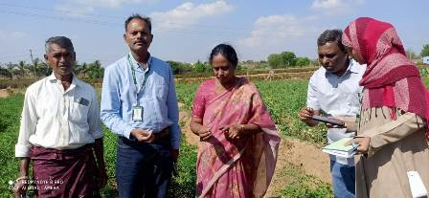
Chilli field and black thrips infestation
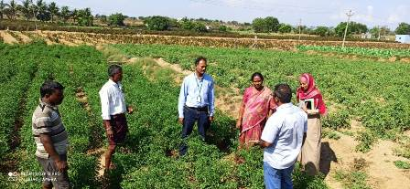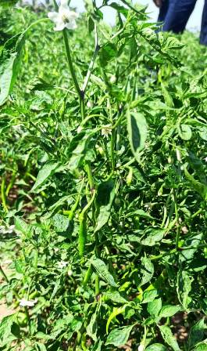
Thrips infested chilli filed visit
Cabbage :
40-50% loss was observed due to rotting of heads caused by heavy rain.
Suggestions: Remove excess water from the field and spray SAAF 2 g/l, create channels to drain off excess water during heavy rains.
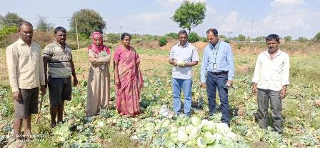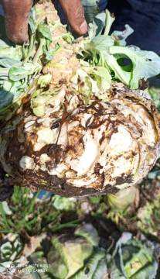
Damaged cabbage field
Details of the farmers and filed visited
SNo | Farmer name | Crop | Acerage | Remarks
1 | Kumar | Rose - Scentu gulabi variety | 2.5 | 40 % less harvest due to heavy rain.Crown gall also found
2 | Narsimhulu | Tomato - Lyco variety | 1.0 | Flower drop due to rain
3 | Bala Naik | Chilli - Ujala variety | 2.0 | Black thrips infested
4 | Narsimhulu | Cabbage | 1.0 | Rotting of heads, severe damage due to rains 40-50 % loss
5 | Nandan Goud | Rose - Bullet variety | 2.0 | Micro nutrient deficiency and thrips damage

Report on “ Visit to hailstorm affected areas in and around Sangareddy”

Dr.V.Suchitra, Senior Scientist and Head of Fruit Research Station, Sangareddy proceeded to hailstorm affected areas on 21.3.2023 along with Scientists of FRS, DHSO Mrs. Sunitha, and Horticultural officers of various mandals of Sangareddy. MLA of Sangareddy, Mr. Kranthi Kumar also visited the affected areas along with his team.

- As per observation by the team an unexpected untimely rains and hailstorms on 19-3-2023 damaged mango, papaya, guava and tomato crops of various villages around Sangareddy. The team noted that the mango crop which was in fruit maturity stage was completely damaged to a percent of 90 to 100 percent in the villages of Bilalpur & Badampet village of Kohir Manda, Kamkole village of Munipally Mandal, Kothur village of Kohir Mandal. The fallen fruits under the trees were observed in all the orchards. Scientific team suggested collection and destruction of fallen fruits away from orchards which may act as source of multiplication of insects & pathogens.
- Team also visited Mohammadapur village of Munipally Mandal where guava fruits which were in marble stage and acid lime fruits which are in marble stage have fallen down in total of 5 acres due to hailstorms. We came to know that large sized fruits of acid lime which are fallen was marketed by the farmers. The damage was observed to be only 10 percent. Scientific team suggested collection and destruction of fallen fruits away from orchards which may act as source of multiplication of insects & pathogens.
- In Kothur village of Kohir Mandal, Papaya in 2 acres was to be damaged 100 percent where large hailstorms had fallen on the crop. The damage in the forms of complete leaf fall, fruit fall was observed.
- In Mohammadapur village of Munipally Mandal, untimely rains affected tomato crop where the fruit fall and fruit rot was observed. To protect against early blight problem scientific team recommended to spray pyraclostrobin @ 1g/lt and to control sucking pest like whitefly acephate @1.5g/lit. and suggested to collect and destroy the fallen fruits away from orchards which may act as source of multiplication of insects & pathogens and suggested to take measures for staking and earthling up in tomato

General recommendations of the affected areas due to untimely rains of Sangareddy
Contingent plan for untimely rains in Central Telangana Zone
Weather condition | Effect | Control measures
Hail storms+rains | Causes partial / complete damage to horticultural crops and fruit trees | Application of urea as foliar spray or KNO3 10g/l to the impacted plants can help them to re grow and develop new foliage.
 | Canopy damage in the form of breaking of branches, uprooting | Wind damaged branches to be pruned and cut ends to be applied with COC or Bordeaux paste
 | Diseases like blight, mould, canker and fruit rots. | streptocylcin
 | Young seedlings may be killed | Irreparable loss. Replanting in annuals or gap filling can be done
 | Fruit and Flower drop occurs | Remove damaged fruits, which will attract insects and which may act as source of multiplication of pathogens.
Heavy winds + rains | Fruit and Flower drop occurs | Do
Untimely rains alone in summer | Favours some plants which are in vegetative stage.  Washes out sucking pests like aphids
 | Increased humidity favours diseases like anthracnose and bacterial diseases in mango
 | Flowering and Seed setting crops like coriander, Ajwain will be washed away resulting in poor yield | Spraying of COC 3g/l for bacterial diseases and DM-45 1g/1l for fungal
 | Turmeric/ Ginger drying and curing will be affected | Spread tarpaulin sheets or store in sheds.
Continuous rains | Waterlogging occurs around the plant. Plants suffer from aeration. | -Provide drainage with in 48  hours.  -Spray and drench COC 3g/l  -Apply fertilizers after rains  -Earthing up in fruit crops
Post rainy days followed by high temperature | Hot and humid weather results in increase in incidence of thrips, mealybugs and hoppers | Spraying neem oil @5ml/l and systemics
 | Favours Weed growth | Run guntaka under optimum soil moisture

Visit to hail storm affected area aling with MLA, Sangareddy Mr. Kranthi Kumar and department officials to mogudampally village
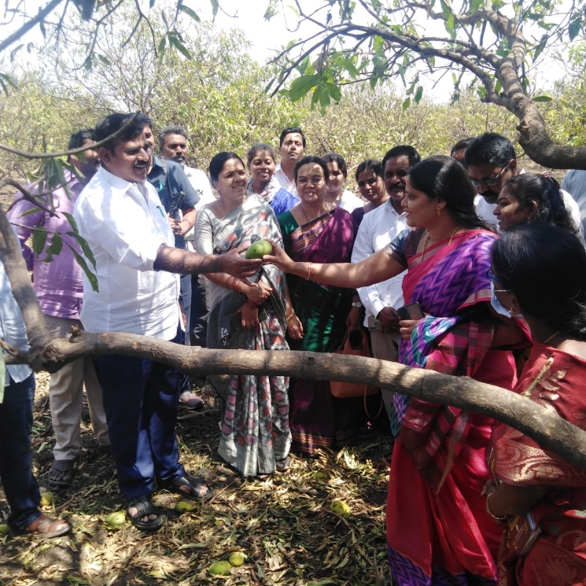
Visit to Kohir village, farmer Saddam Mango orchard along with Scientists of FRS
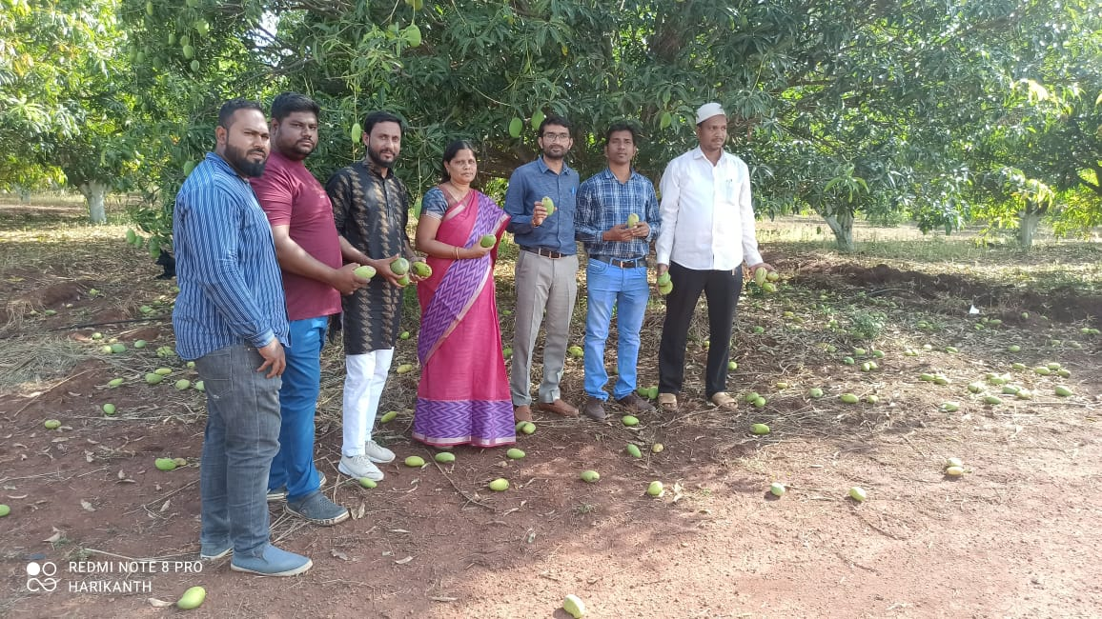
Training program on Climate Change in collaboration with Department of Horticulture at FRS, Sangaraeddy on 21.3. 2023
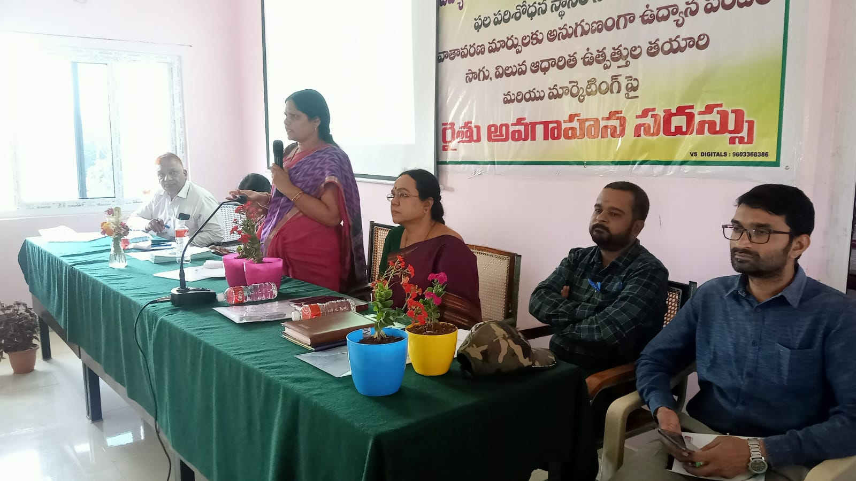

Compliance Report on “Contingency plan during unseasonal rains” by
Horticultural Research Station, Aswaraopet
I, Dr. G.Vijay Krishna, Scientist (Hort.), HRS, Aswaraopet, visited and observed the horticultural crops viz., Papaya, Oil palm, Chilli intercrop in oilpalm and Tomato affected with unseasonal rains and made the suggestions. As per Cir. Memo. No. 96/SKLTSHU/2022-23 of Director of Research, SKLTSHU, Dated on 20-03-2023, survey was taken up by Dr. G. Vijay Krishna, Scientist (hort.) & Head, HRS, Aswaraopet along with Sri. G. Sandeep Kumar, Horticulture Officer (CLHSO), Khammam on 20-03-2023 and 21-03-2023 in Khammam (Mandal and District). The Horticulture orchards (Papaya, Oil palm, Chilli as intercrop in oilpalm and Tomato) in following villages were surveyed:
- Manchukonda
- Erlapudi
- Pangidi
Observations Made:
- Papaya crop is at fruit development stage, harvest has to be done and observed fruit drop in immature fruits.
- 10-20% of papaya plants observed in fallen condition.
- Tomato crop is at fruit set stage and observed flower drop due to unseasonal rains.
- Chilli crop is at fruit maturity stage and observed lodging of chilli plants (10-20%) in Chilli as intercrop in oil palm orchard
- There is no crop/plant damage observed in oil palm orchard due to unseasonal rains.
Suggestions made:
- Papaya:
- Drain out the excess water stagnated in orchards
- Recommended earthing –up and staking in fallen plants
- Recommended to sale the fallen fruits as soon as possible to the local market
- Suggested to drench the plants with copper fungicides to prevent collar rot
- Spray of 1 % KNO₃ or Urea 2% solution 2-3 times.

- Chilli as intercrop in Oilpalm:
- Drain out the excess water
- Recommended earthing –up to fallen plants
- Suggested to spray Urea 2% solution 2-3 times
- Recommended top dressing of fertilizers 15 kg MOP & 30 kg Urea per acre as booster dose.

- Tomato:
- Drain out the excess water
- Recommended earthing –up to fallen plants
- Suggested to spray of polyfeed @ 2-3 g/l
- Recommended to spray mancozeb 2.5 g/l as preventive measure to control phytopthora diseases.

- Oil palm
- Darin out the excess water if water stagnation conditions observed
- Recommended to spray carbendazim @ 1g/l

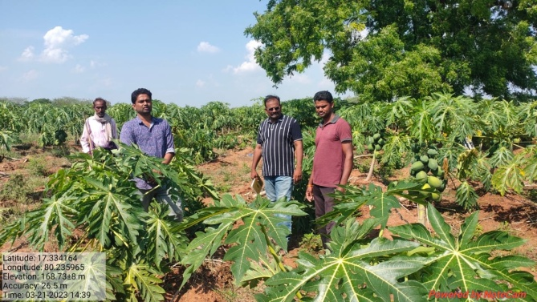 | 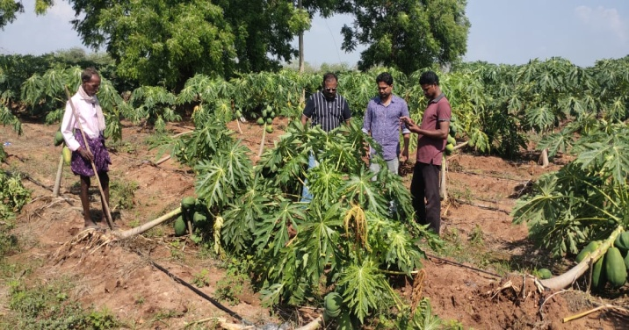
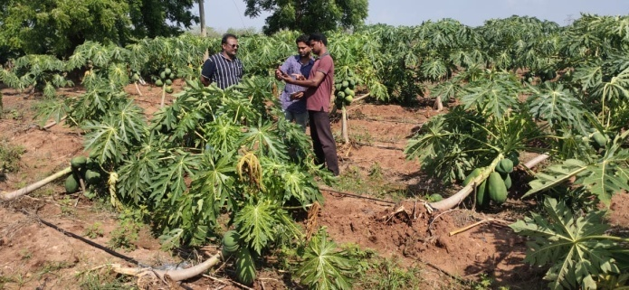 | 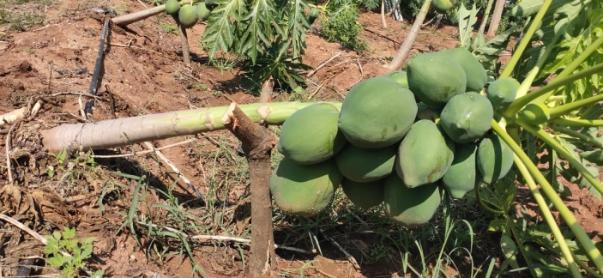
Recommending precautionary measures during unseasonal rains to papaya farmer in Manchukonda (V.), Khammam (M&D)
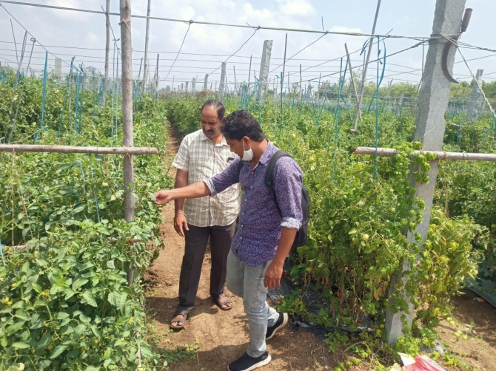 | 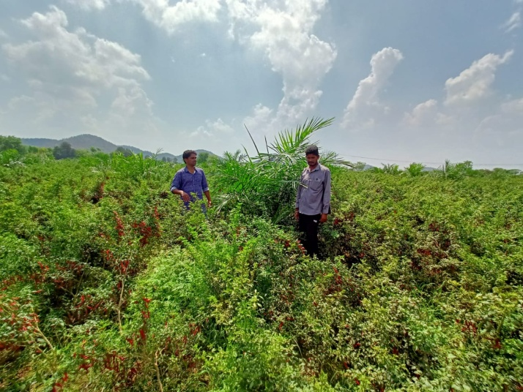
Recommending precautionary measures during unseasonal rains to Tomato farmer in Erlapudi (V.), Khammam (M&D) | Recommending precautionary measures during unseasonal rains to Tomato farmer in Pangidi (V.), Khammam (M&D).

HORTICULTURAL RESEARCH STATION, KONDAMALLEPALLY

CONTINGENCY PLAN DURING UNSEASONAL RAINS IN TELANGANA

Dt: 21.3.2023
Today we visited marriguda and mall villages of Nalgonda district to estimate damage of crops due to unseasonal rains on 18th march, 2023in Telangana and following mandal wise crop damages occurred in Nalgonda district. Further, we have given contingent plan for recovery due to heavy rains/ Hail storms.

s.no | Name of the village | Crop name | No of farmers | Per cent of damage due to unseasonal rains
1 | Marriguda | Acid lime, sweet orange, Ber | 10 | <33%
2 | Mall | Acid lime, sweet orange | 7 | <33%

Contingent plan for Acid lime and Sweet Orange:
- Water logging should be removed immediately by making surface channels and trenches and Water in the basins around the trunks should be removed.
- After recovery from water logging, apply 19:19:19 @ 5 g/l followed by micro nutrient mixture consisting of Zinc, Boron, Iron, Manganeese at 2.5 gm/liter.
- Removal and destroy of dead and infected twigs in the orchards.
- Weed should be removed as they act as secondary host for citrus fruit sucking moth. If any sucking pests like whitefly, psyllids, blackfly, mealy bug appears spray profenophos @ 1.5 ml/lit or imidacloprid @ 0.5 ml/lit of water.
- In orchards, where phytophthora gummosis is observed on the trunks, the affected area should be cleaned with a sharp knife.
- Recommended Fertilizer dose should be applied as per the schedule to prevent leaching losses.

Contingent plan for Ber:
- Damages branches should be pruned and the cut surfaces should be applied with Bordeaux paste/paste.
- In heavy soils where soils take longer time to dry, light ploughing after the rains to facilitate faster depletion of soil moisture is recommended.
- Recommended Fertilizer dose should be applied as per the schedule to prevent leaching losses.

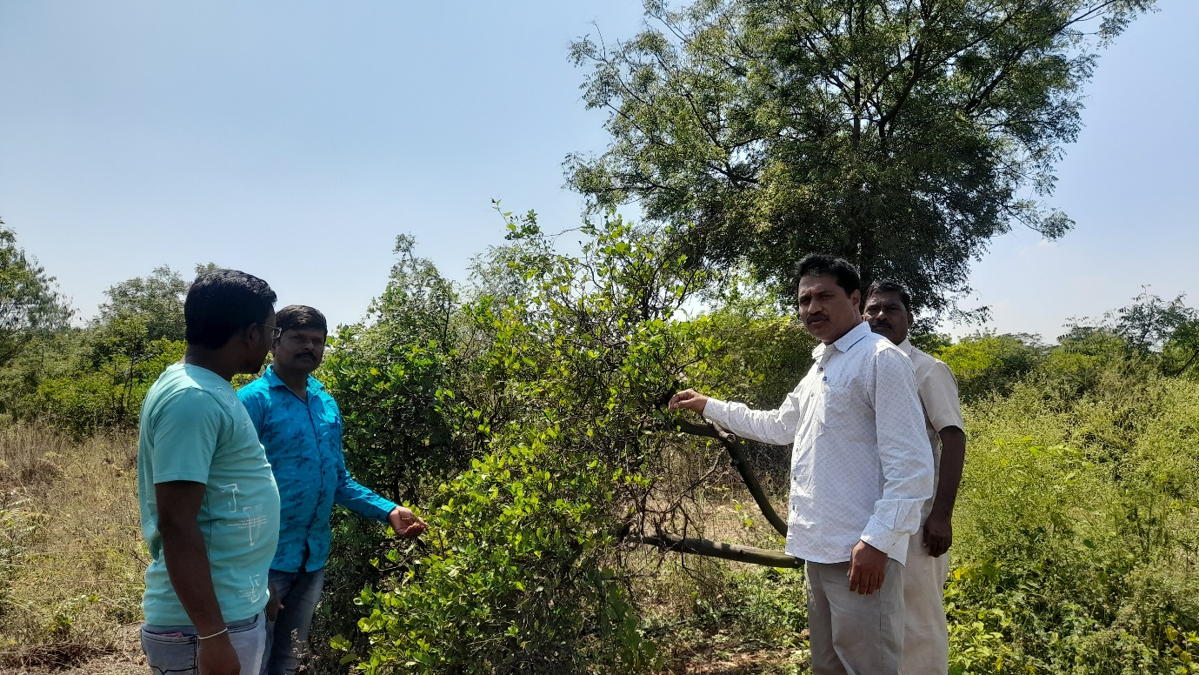
Damaged acid lime in farmer’s field

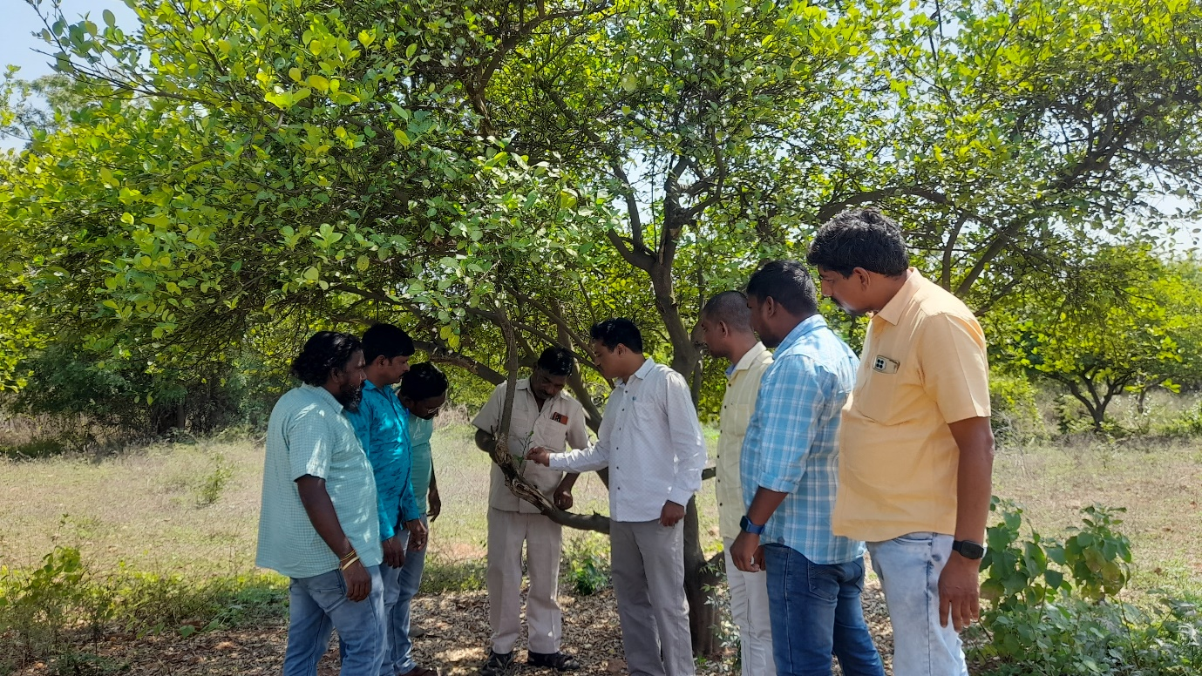

Observing damage due to heavy rains in farmer’s field
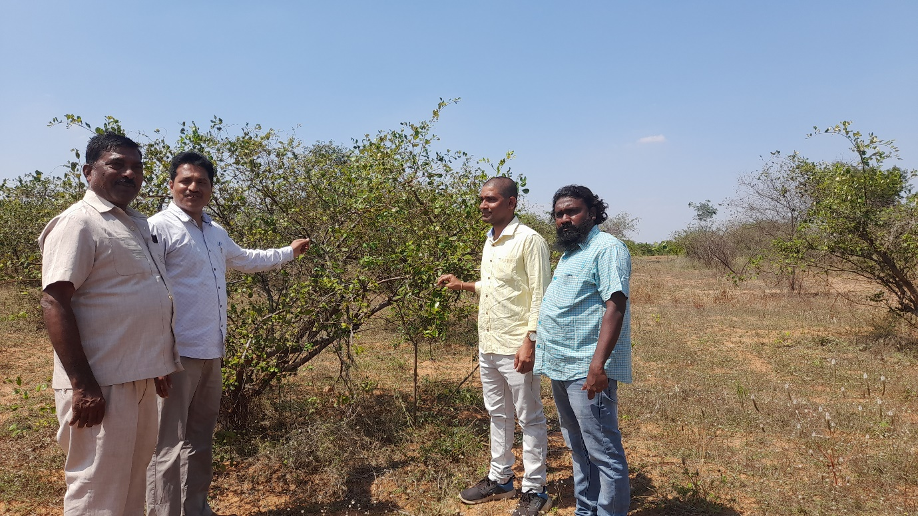
Observing Ber crop at farmer’s field

REPORT ON VISITS TO GRAPE ORCHARDS AFTER THE UNSEASONAL RAINS AND CONTINGENCY PLAN FOR GRAPE FARMERS
In view of untimely rains in Telangana state Grape orchards were surveyed on 18.03.2023 and 21-03-2023 to observe the current situation of the orchards and to give suggestions. Survey was taken up by Dr. K. Venkata Laxmi, Scientist (H) & Head, Dr. K. Venkata Ramesh, Scientist (Plant Pathology), Dr. K. Prabhavathi, Scientist (Soil Science) along with Smt. Neeraja Gandhi, DHSO & Smt. Renuka, Horticulture Officer in Keesara, Mudichintalapally and Shameerpet mandals. The grape orchards in the following villages were surveyed.
- Thimmayapalli
- Cheeryala
- Dharmaram
- Keesara
- Tumukunta
- Koltur
- Potharam

Observations Made:
- Most of the orchards are yet to be harvested and only 20% of the crop was harvested so far.
- Grape crop is at different stages. Some are nearing maturity and some need 30-40 days more for harvest.
- Initiation of cracking of berries is observed due to untimely rains and this may increase in the coming days.
- Rotting of berries is also observed in some orchards.
Recommended measures:
- Avoid water logging in the gardens.
- Harvesting of crop should be completed at the earliest if they have reached maturity without any delay as there would be berry cracking and rotting due to the recent rains.
- Removal of cracked berries manually after cessation of rains.
- Spraying of Azoxystrobin 1 ml/litre with pre harvest interval of 7 days.
- Spraying of Chitosan 2 ml/litre to avoid berry rotting in gardens where fruits are ready for harvest,.
- Spraying of Trichoderma viride + Bacillus subtilis consortium 5 ml / litre increases the antagonistic activity against berry rotting pathogens.
- Spraying of CaNO₃ 2 gm/liter for improving the fruit quality and reducing fruit cracking.
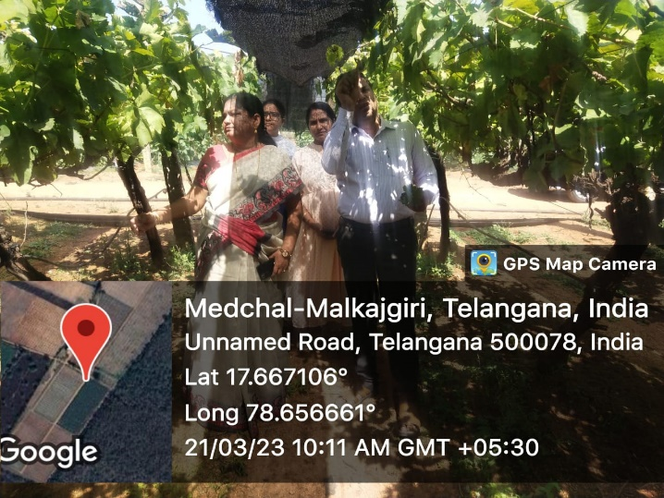 | 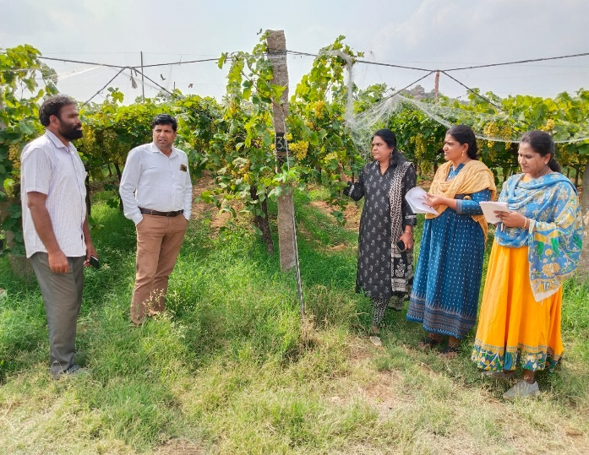
Field visit at Koltur | Field visit at Thimmayapalli
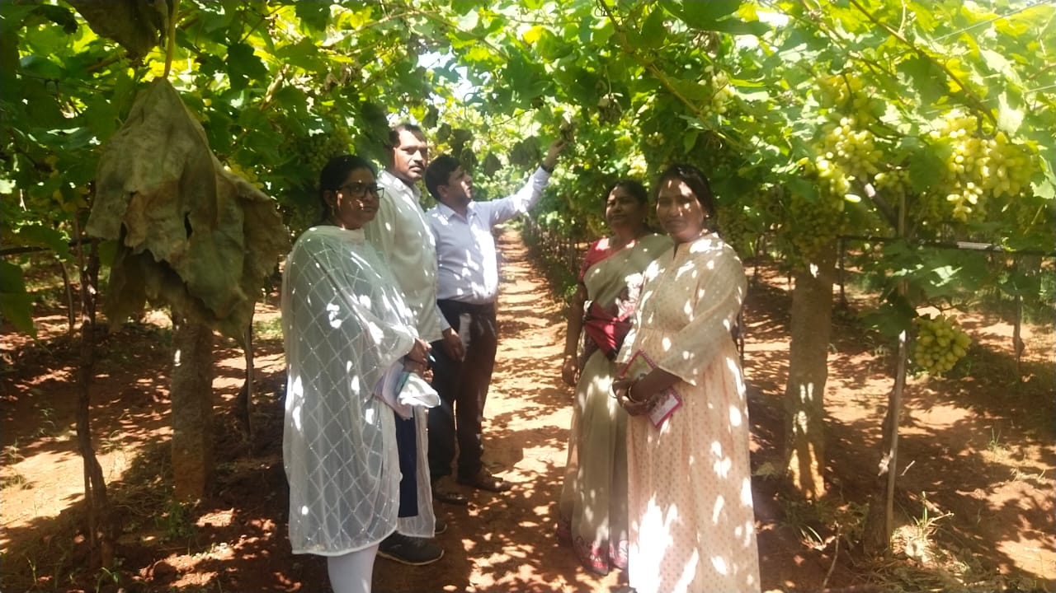 | 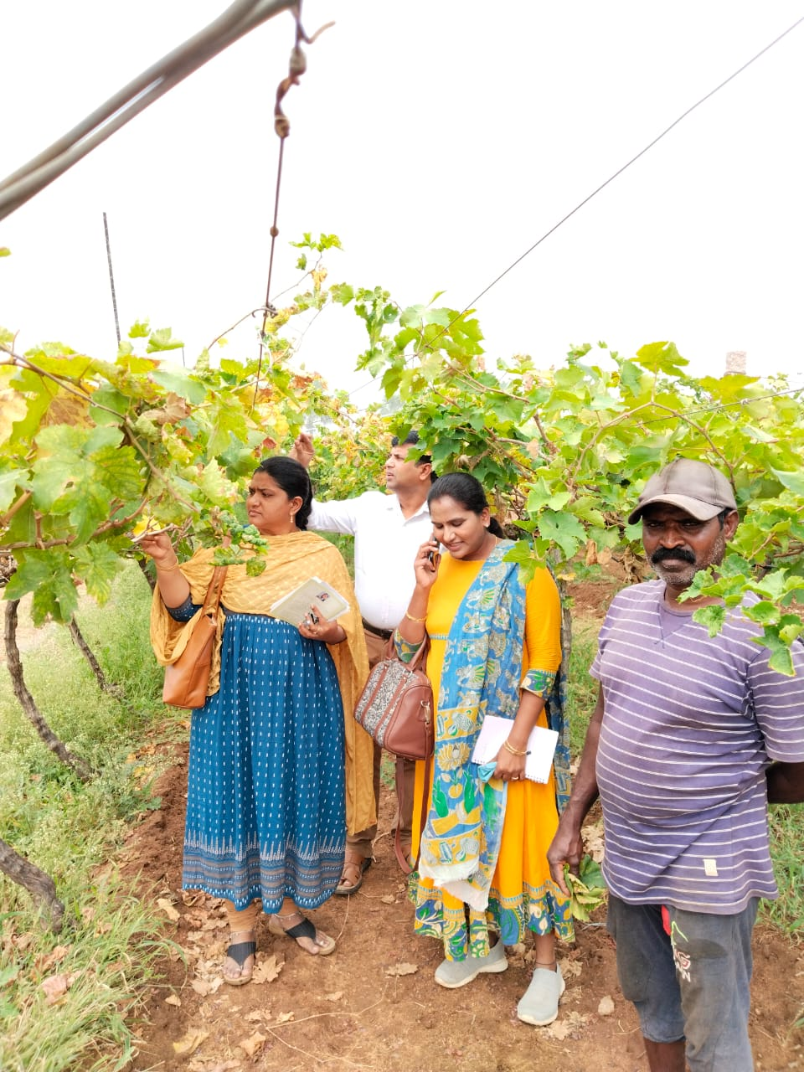
Field visit at Potharam | Field visit at Keesara
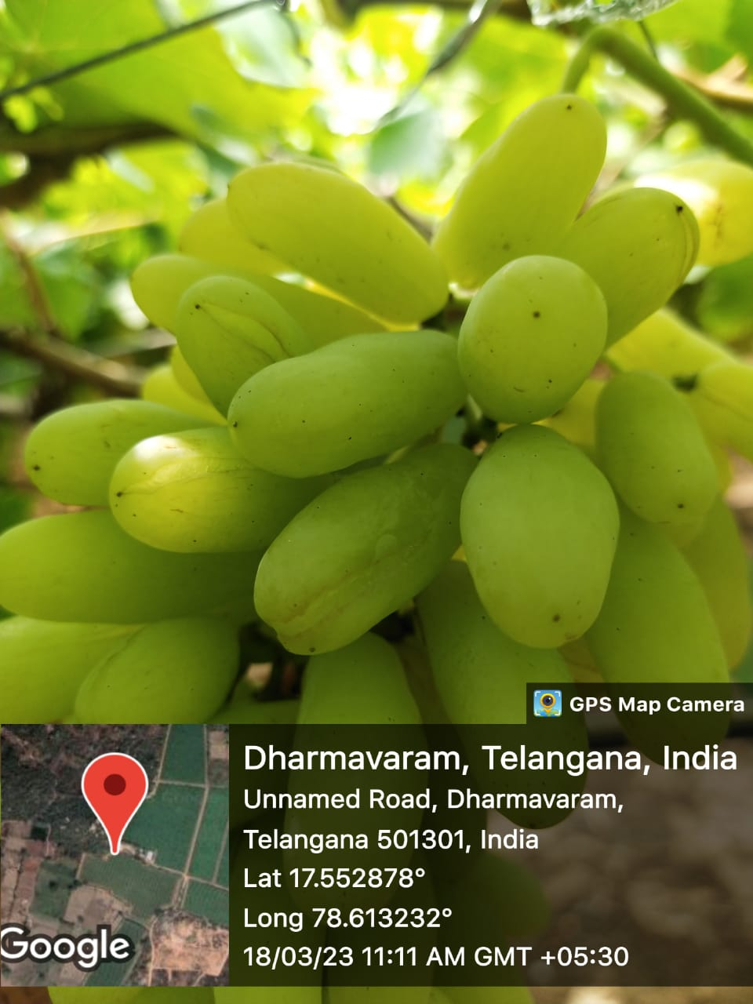 | 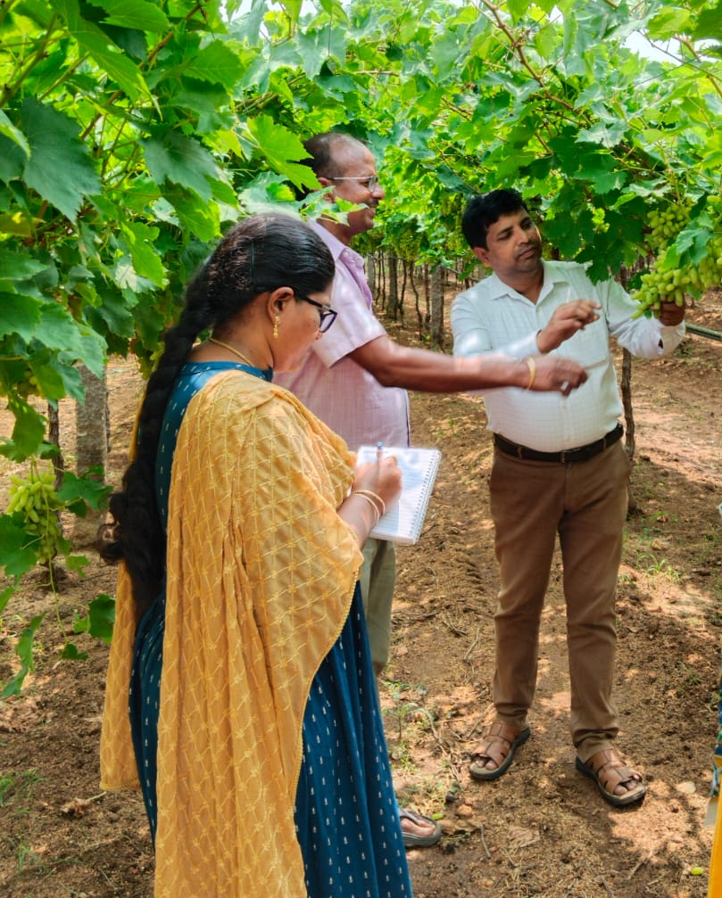
Berry cracking | Field visit at Dharmavaram
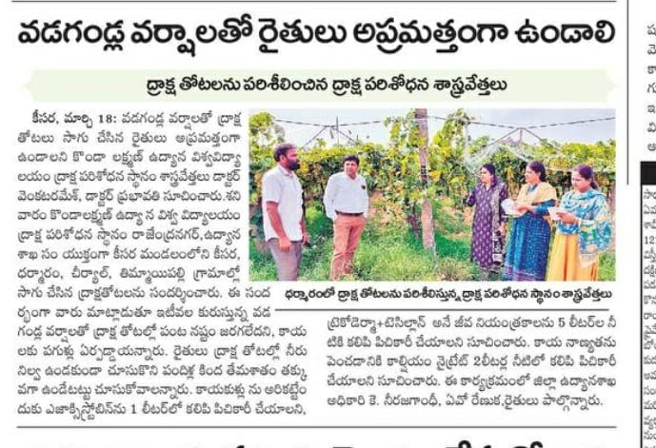
Namaste Telangana 19.03.2023

JVR Horticultural Research Station, Malyal, Mahabubabad Dist.
I, K. Bhasker, Scientist (GPBR), JVR HRS, Malyal, visited and observed the horticultural crops viz., Chilli, Cluster Bean, Bitter Gourd and A. Prashanth Kumar, Scientist (Pl.Path) has visited the Turmeric crop which is at post-harvest stage affected with unseasonal rains and made the suggestions. As per Cir. Memo. No. 96/SKLTSHU/2022-23 of Director of Research, SKLTSHU, Dated 20-03-2023, survey was taken up by K. Bhasker, Scientist (GPBR) & Head and A. Prashanth Kumar, Scientist (Pl.Path), JVR HRS, Malyal on 21-03-2023 separately in Mahabubabad district. The Horticultural crops in following villages were surveyed:
- Chokla Thanda, Mahabubabad Mandal
- Nerada, Kuravi Mandal
1. Chillies:
Post Harvest Stage
- Drain the excess water as soon as possible in the drying plat forms.
- Dry the pods on elevated concrete floor/polythene sheet immediately after the appearance of sunlight. Dry the chillies till it produces rattling sound (10-11% moisture).
- Grade the pods and market as soon as possible.
- Do not store such produce for long periods.
- Market the produce as soon as possible.
2. Turmeric:
Post Harvest Loss:
- Seed rhizomes: Turmeric rhizomes are heaped & covered with the Tarpaulins sheets in a well- ventilated shed up to cessation of rains.
3. Cluster Bean and Bitter Gourd:
- The rain water was flowed on to the crop.
- Suggested to drench the COC @ 3.0 g/lit to avoid the chances of wilting of plants.
- And also recommended to spray potassium Nitrate @ 5 g/lit for 1-2 times.

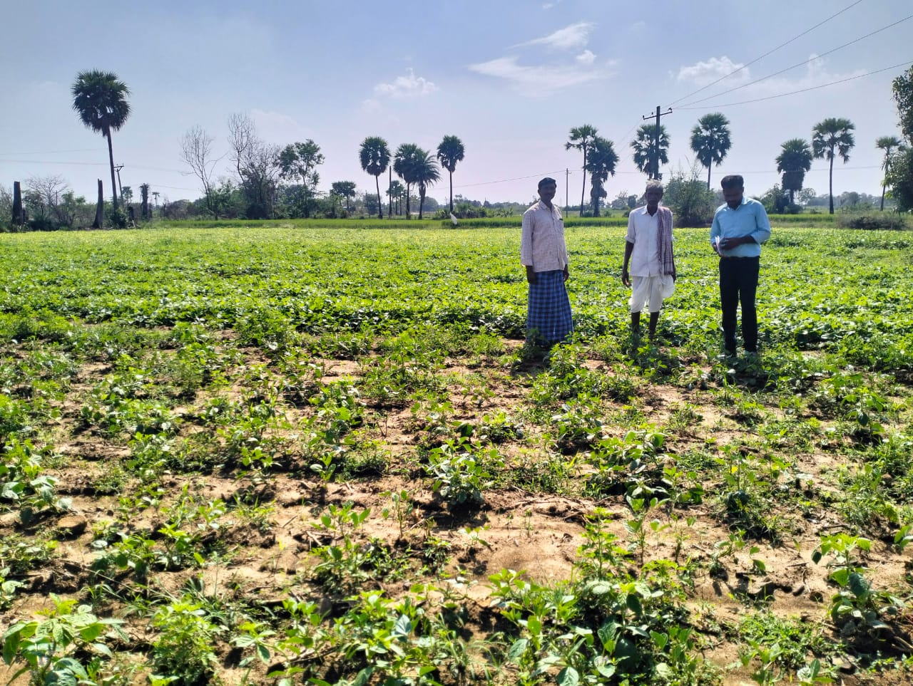
Cluster Bean Crop
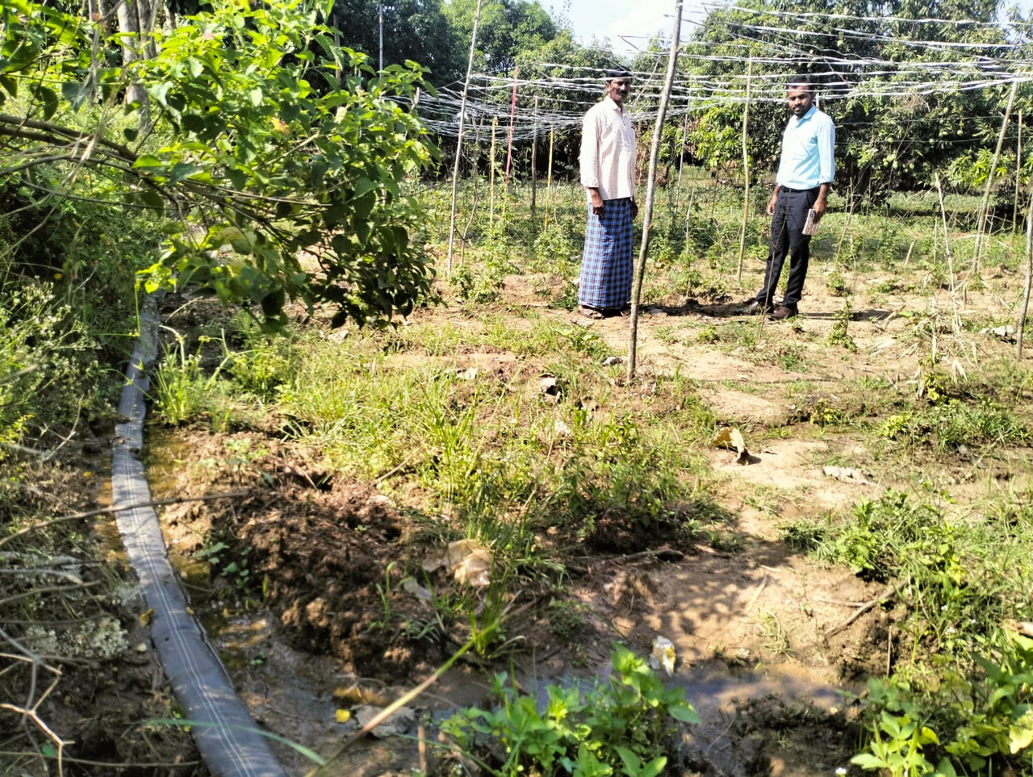
Bitter Gourd Crop
Crop damage particulars due summer rains and contingent plans in Nizamabad district during March 2023
This research station has surveyed the crop damage fields of horticultural crops due to rains & hailstorms during March 2023 along with concerned HO and the particulars are given below.
Crop damage particulars of Nizamabad district
S.No | Crop | Damage in acres | Remarks
1 | Mango | 40 acres | Unripe fruit drop
2 | Vegetable | 5 acres | Crop lodging
3 | Turmeric | Post harvest loss 10 acres | -

Turmeric crop
The steam boiled turmeric are dried under open or polythene or cement plot forms under natural sunlight for 12 to 15 days. The dried rhizome wetted due to rains, the color and market price will be reduced.
Suggested: Visited the drying platforms and asked to cover the polythene sheet and arranging the drainage channels, if heavy rains but very less damage was noticed.
2. Normally farmers are preserving the turmeric seed material (Rhizome) in open fields or under shade tree or under shade of iron top with covering the dried turmeric leaves.
Suggested: The seed material of turmeric may preserved under rain proof places with covering the dried turmeric leaves as to avoid the rotting.

Field visit / drying platforms of turmeric ( March 2023)
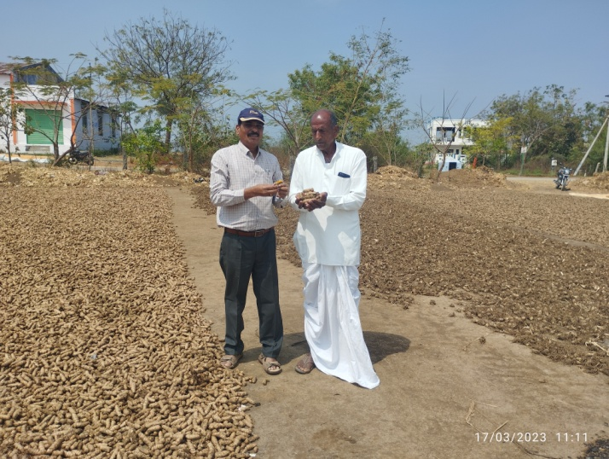  Visit at Subiryal, Armmor | 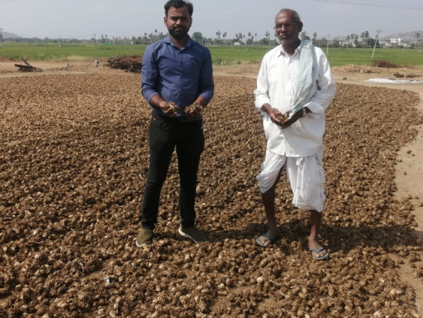  Visit at Velpur
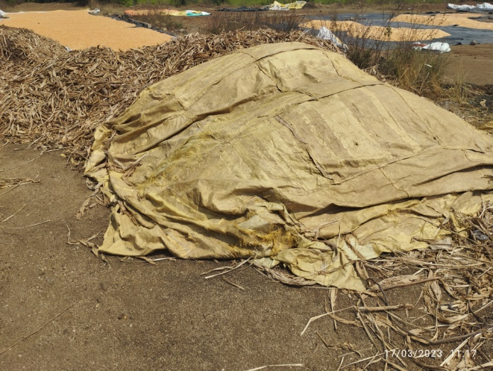  Seed preserved under polythene sheetssheetsbags | 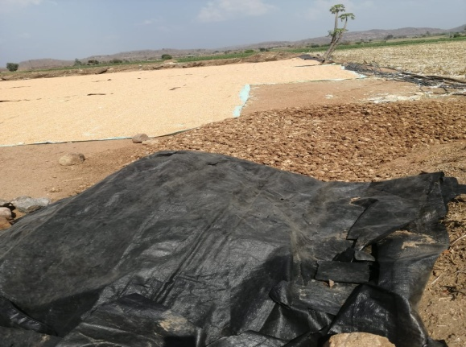  Boiled rhizomes covers under plythene sheets
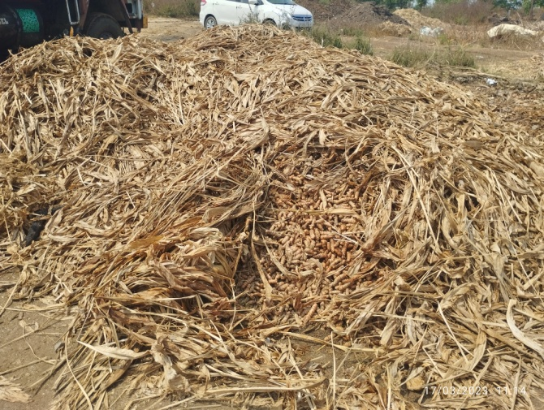
Seed preservation in open fields

